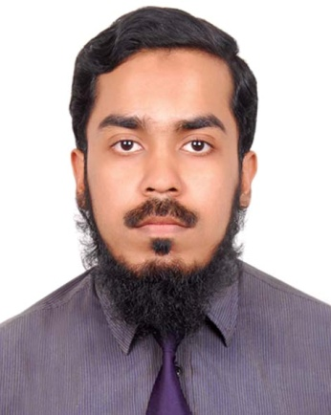

Ubaidur Rahman
House# 22, Road# 4, Sector# 13,
Uttara, Dhaka 1230.
Tel: 02 5895 3136
Mobile: 01835397597
E-mail: ubaidurrahman31@gmail.com

Career Objective:
To enhance technical skills and to provide energetic services, with consistency and honesty.
Working Experience:
1. Executive-SCM, Super Star Group Ltd.
(11 December 2016 – 8 August 2017)

2. Project Engineer, Tokyo Development Engineers Ltd
(22 April 2015 -10 December 2016)

3. Trainee Engineer (Site Supervision), Taqwa Design & Development Ltd.
(9 September 2014 - 9 December 2014)

Academic Qualification:
 | Group/Major | Institute | CGPA | Year
MBA | SCM | Bangladesh Universty of Professionals | 3.31/4.00 | 2017
BSCE | RCC | IUBAT | 3.63/4.00 | 2014
HSC | Science | BAF Shaheen College Kurmitolla | 4.5/5.00 | 2010
SSC | Science | Shaheed Manu Mia High School | 4.19/5.00 | 2008

Summary of Qualification:
Computer skills: AutoCAD 2010, ETABS 9.2, Microsoft Office, C programming.
First Aid Training: Trained & Certified by Red Crescent Society Bangladesh.

Language Skill:
Excellent in speaking, reading and writing in both Bangla and English.

Personal Information:
Father’s Name : Late Wg. Cdr. Delwar Hussain Rary (Rtd)
Mother’s Name : Jahanara Begum
Date of Birth : 31st August 1992.
Nationality : Bangladeshi by birth
Religion : Muslim
Marital Status : Single
Blood Group : O+
Permanent Address : House# 22, Road # 04, Sector # 13, Uttara, Dhaka-1230.

References:
1. Rahmatullah Nazim
Civil Engineer
DALCO Building Systems
House# 4, Road# 14, Baridhara,
Dhaka 1212, Bangladesh.
Cell: 01535 899292
Relation: Brother

2. Niamotullah Azim
Merchandiser
Puls Trading Far East Limited
(H&M Group )
House No. NW (K) 8/A, Road No. 50,
Gulshan-2, Dhaka 1212, Bangladesh.
Tel: +88 0960 9000466 Extn. 5311
Cell: 01777 753474
Relation: Brother

(Ubaidur Rahman)
Date:

